When defending your interests turns into an aggressive lobby battle
The controversial case of the Copyright Directive

Victor Garcia Lopez
College of Europe

Abstract: In September 2016, the European Commission launched a reform of the Copyright Directive. This legislative act caught the attention of many interest groups, who started to campaign with the aim of defending their interests in a multi-level governance system. The interactions among different stakeholders when defending their respective positions turned into a lobby battle between the two main opposing sides ahead of this piece of legislation: ‘those who want a Europe for creators’ vs. ‘those who fight for saving the internet’. This article studies the different tactics deployed by these two opposing sides through the Keller’s approach on quiet and noisy politics, emphasizing how crucial the interaction among interest groups and policymakers is for drafting legislation. More specifically, the present text analyses the strategies exerted by interest groups over the European Parliament, with the aim of studying to what extent the coalitions formed shaped the new provisions of this controversial legislative text.
Keywords: Copyright Directive, interest groups, content creators, tech giants, noisy politics.

Resumen: En septiembre de 2016, la Comisión Europea presentó una reforma a nivel europeo sobre los derechos de autor. Dicho texto legislativo captó la atención de varios grupos de interés en el sector, que intentaron por todos los medios defender sus intereses. Aquello que comenzó como una simple defensa de intereses rápidamente se convirtió en una auténtica ‘batalla de lobby’ entre los dos principales grupos de interés: ‘aquellos que querían una Europa para los creadores” frente a ‘aquellos que luchaban por la supervivencia de Internet’. Este artículo estudia, a través del enfoque de Keller sobre aquello que en inglés se considera como ‘quiet and noisy politics’, las diferentes tácticas llevadas a cabo por estos dos grupos con intereses opuestos, haciendo hincapié en la interacción entre grupos de presión y dirigentes políticos como elemento clave para la redacción de una determinada norma, en este caso, la Directiva de derechos de autor. De forma más concreta, este artículo analiza las diferentes estrategias que dichos grupos de interés desarrollaron en el Parlamento Europeo con el fin de estudiar hasta qué punto las coaliciones formadas influyeron en el proceso de redacción de esta Directiva que ha sido tan polémica.
Palabras clave: Directiva de derechos de autor, grupos de interés, creadores de contenido, gigantes tecnológicos, noisy politics.

Introduction

New technologies raise new challenges. A new digital era is approaching, the digital environment is constantly evolving, and legislation must go hand in hand with the technological breakthroughs. Once Mr. Jean-Claude Juncker was named President of the European Commission, ten main priorities were set up. Indeed, the first one aimed at increasing growth and employment whilst creating a digital single market that “brings down barriers to unlock online opportunities”. In this way, the Juncker Commission was committed to “modernising the EU copyright rules to fit the digital age” with the aim of bringing a new legislative framework where the existing and the new actors could operate on a level-playing field market.

On those grounds, the European Commission, once discovered the existing fragmentation among Member States over the copyright sector, launched a reform of the Copyright Directive in September 2016. The aim was to take a step forward on protecting rightsholders and ensuring legal certainty whilst closing existing legal loopholes. Nevertheless, the launch of this legislative proposal was not welcomed by all the interest groups who were going to be affected by these new rules.

Over the course of drafting this piece of legislation, a wide variety of different actors got involved in the legislative process. At a time where the vast majority of national laws come from the EU, it is more important than ever to know how EU legislation is drafted. At a European level, the interactions among interest groups and policymakers is something that people take for granted. Against this backdrop, it is essential to understand how the expertise and knowledge of public affairs professionals contribute to the elaboration of the different pieces of legislation that the EU adopts on a daily basis. Therefore, the majority of the legal provisions used at a national level are the result of a bargaining process among interest groups and policymakers at a European level.

In this regard, the lobbying sector and the application of law are highly interconnected. Within the Copyright Directive, interest groups made coalitions that clearly reflected the two main sides of the coin of the stakeholders involved. The first category of actors encompassed ‘those who want a Europe for creators’, who represented the pro-copyright side, and the second category covered ‘those who fight for saving the internet’, who did not agree at all with the content of this reform.

This article aims at studying the lobby battle between the abovementioned coalitions over a specific piece of legislation: the Copyright Directive. When mentioning ‘lobby battle’, it refers to the fact of having two opposing coalitions of interest groups who are confronted over the same piece of legislation, trying to influence it by developing striking campaigns and opposing arguments to defend their interests. To address this complex issue on a structured way, a general overview about the copyright rules at a European level will be given first, including a brief description about the main provisions of the copyright reform, and about the main actors involved. Afterwards, the tactics deployed over the European Parliament by interest groups will be addressed.

- The Copyright rules at a European level

At a European level, there is not a unified legal framework concerning copyright law. The EU copyright sector is fragmented because its rules still remain at a national level, where strong specificities are contemplated on the national legal frameworks of Member States. Considering that the previous piece of legislation covering the matter was issued in 2001, after 15 years there was a real need of complementing and adapting those rules. This is why the European Commission launched a copyright reform in September 2016.
This reform aimed at harmonising EU copyright rules in order to root out fragmentation on the single market. There was a real need in the market to adapt those provisions to the new digital environment that affects education, research and cultural heritage, among other aspects. Furthermore, the proposal was also seeking to ensure a fairer remuneration for creators, since they do not often receive an adequate return for the online distribution of their works.
Among other important provisions, the two most conflictual aspects have been the Article 15 and the Article 17. On the one hand, the first one was introduced with a view to protect and fairly remunerate press publishers against some anticompetitive practices that were taking place on the market. On the other hand, Article 17 was intended to get rid of unauthorised content that is present in online platforms, and for achieving it, it suggested a strong cooperation between content creators and user-generated platforms.
Owing to the large number of stakeholders affected, this piece of legislation generated a huge confrontation among the different interest groups involved, leading to the formation of two big coalitions that could be classified as ‘those who want a Europe for creators’, and ‘those who fight for saving the internet’.

Within the first group, we could find “organisations representing authors, composers, writers, journalists, performers, photographers and others working in all artistic fields, news agencies, book, press, scientific and music publishers, audio-visual and independent music producers”. For them, the Copyright Directive would provide with a fairer compensation, apart from granting them with more protection of the content they create. Contrary to what those actors believe, the other side of the coin considered that this piece of legislation was going to kill the Internet through filtering online content. This second group of actors was composed by tech giants (mainly Facebook, Google and YouTube), digital associations and NGOs (non-governmental organisations) that defend rights and freedoms online (such as EDRi and EDiMA), and civil society actors.

The present case is very singular due to the massive lobbying and different actors that have been involved along the European policy-making process. Moreover, the fact that there are two sides entirely and bitterly confronted makes this case unique for further study. According to Jean-Marie Cavada, former MEP from ALDE group and shadow rapporteur from the legal affairs committee (JURI), this report has been the more changing and controversial legislative text during his last 15 years of mandate, as it will be demonstrated below.
- What if the walls of the European Parliament could speak?
Once the legislative proposal was launched, the European Commission passed the ball to the co-legislators. Long gone are the days when the European Parliament (EP) was just a consultative body. Since the Treaty of Lisbon granted this institution with full legislative powers, it has become co-legislator, together with the Council. As is usually the case in a Multi-Level Governance (MLG) structure, the EP and the Council, have been subjected to a massive lobbying campaign executed by the interest groups involved.

One of the most intense lobbying periods of this piece of legislation took place between June and September 2018 over the EP. On 20th June 2018, the responsible committee (JURI) considered that, after the report was adopted in committee, it was time to open the interinstitutional negotiations period. Nevertheless, when this outcome arrived at plenary session, the MEPs voted against it on 5th July 2018. This decision did not happen by accident. It was actually the result of a massive lobbying campaign that interest groups exerted during the run-up period to the vote.

As outlined by the MLG framework, European policies are the result of a convoluted process of negotiations between governmental and non-governmental actors. For analysing this convoluted process within the EP, the approach on quiet and noisy politics will be presented. This theory defended by Eileen Keller will be the theoretical framework to explain the contrasting lobbying tactics executed by the involved interest groups. In the same vein, the negative vote of the European Parliament on July, as well as the positive vote in September, and its reasoning behind, will be analysed in this section.

According to Eileen Keller, business politics could be seen either as quiet or noisy politics. On the one hand, quiet politics entails a strategy focused on interest groups’ expertise. Therefore, a direct contact between policymakers and pressure groups is needed in order to convince decision-makers that acting on a certain way – according to the interests of those specific pressure groups – is the best way to modify a given proposal. In this sense, data, empirical evidence and contrasted information play a key role for influence politicians. In the same vein, information is crucial for policymakers and, those interest groups who focus on providing high amount of information to decision-makers are those who normally tend to have a higher impact on the final text.

On the other hand, noisy politics is less technocratic and more focused on what the consequences – mainly political – that the approval of a given policy could entail. Moreover, it also focuses on the respective demands of the constituencies as an important aspect to bear in mind for policymakers when making usage of a decision. This approach also gives importance to the manipulation of the salience of a policy through different channels, such as campaigning on the public opinion and other tools for creating awareness. The interest groups who use this noisy approach normally try to convince politicians that a certain policy is fair or unfair according to their interests. If we apply these approaches to the piece of legislation that we are discussing, one could say that the quiet politics side is represented by ‘those who want a Europe for creators’ and the noisy politics side is depicted by ‘those who fight for saving the Internet’.

As previously indicated, in July 2018, MEPs decided to do not enter into interinstitutional negotiations on the Copyright Directive. To be more accurate, 318 MEPs considered that the draft text was not ready yet to go into trialogues. This decision was welcomed with open arms by ‘those who fought for saving the Internet’, especially by tech giants. For them, it tasted as a partial victory because this was the result of the massive lobbying campaign made beforehand. As a matter of fact of how those groups have played with noisy politics, it could be mentioned the massive email campaigning done during the period before the July vote, when MEPs had their inboxes full of emails claiming for a negative vote on the Copyright Directive.

“When it came the vote in plenary in July, MEPs received thousands of emails. The majority of the MEPs were a little bit afraid and not understanding what was going on”. Tech giants managed to scare politicians whilst mobilising the public opinion. Some of the MEPs who were not part of the involved committees within this piece of legislation voted against it “in order to get more time to be informed” after the big email campaigning. To be more precise, members of the office of the Swedish MEP Max Andersson, from the Greens group, stated that within the period comprised between May and September 2018 they received over 3.000 emails.

This campaign was not the first time ever seen at the EP. As a matter of fact, there was a very similar case that took place on 2003 on the Directive on the Patentability of Computer-Implemented Inventions where the outrageous e-mail campaign generated two different effects on MEPs, as it happened on the Copyright Directive. Some of them started to think that something was not right with JURI’s report and needed more time to think about their vote, whereas some others just felt harassed and they did not agree with this kind of aggressive lobbying strategies.

Tech giants and associations that defend online freedoms shared their very large network of contacts among decision-makers, but the presence of YouTubers allowed them to reach a more general public, and therefore influence the public opinion. Moreover, civil society actors have contributed to spread the message among the public as well. In the same way, there was a clear ally from the EP; MEP Julia Reda from the Greens, who has been extremely involved in social media and within the institutions, fighting for the rejection of the Directive.

As a matter of fact, one of the consequences of this campaign based on social media was the access of information to all type of audiences. Since young Youtubers were claiming for a rejection of this legislative text, the issue reached a non-usual audience on European politics: the kids. There was even a little confrontation between two Greens MEPs on Twitter regarding the encouragement of kids to lobby their parents on this issue made by Julia Reda (see annex I). Indeed, some MEPs’ children were asking their parents why they wanted to kill the internet. “MEPs were surprised that their kids were against them; reason why some of them though it was a borderline and unfair tactic”.

But not only this, the campaign went even further. The social media account of one Portuguese MEP from ALDE group, who publicly expressed his support to the Articles 15 and 17, got hacked. According to him, this was the ‘result of a coordinated lobby effort’ and a proof that everyone could get manipulated by tech giants. Besides this campaign, the effect that political constituencies could have on decision-makers in terms of electoral consequences was raised by the ‘Copyright for Creativity’ campaign.

This declaration was supported by non-profit organisations and associations which defend online rights and freedoms, among others. They launched a campaign before the vote took place on JURI committee on June 2018 for encouraging people to send an email to the MEP of their constituencies. Through this tactic, they wanted the public – potential voters – to direct contact their representatives in order to increase the popularity and the salience of the issue among their elected agents whilst hiding the names of the real companies which were behind this action. This campaign collapsed MEPs’ inboxes and they were fed up with hundreds of similar phone calls. It was not possible to reach out people through social or conventional media as they were covered with negative views all over. “It was unbelievable, they reached a situation where interest groups tried to shout, but nobody could hear them”.

Apart from those tactics, they deployed more visual actions with the aim of raising awareness on the public opinion. As an illustration, at the end of June three trucks were parked in Place Luxembourg, in front of the premises of the European Parliament in Brussels, with enormous banners claiming against the approval of the Copyright file. As it could be seen in annex II, they were directly addressing policymakers questioning their job whilst rhetorically asking them if they were going to ignore what the public opinion, and therefore their constituencies, were telling them.

In the same way, the most striking campaign was deployed by YouTube, which decided to place pop-ups in the bottom left-hand corner of their website. Within these pop-ups, some messages regarding the terrible consequences of approving former article 13 (article 17 in the final text) were spread, as well as some information about what this article was about (see annex III). This is how they managed to raise awareness among the public opinion, becoming the main driver of the debate.

Up until this point, the tactics followed by ‘those who wanted a Europe for creators’, remaining on the other side of this lobby battle, were in line with the ‘quiet politics’ approach previously exposed. They were more focused on direct contact with policymakers. In Brussels, “precise timing is an art” and this is why they were focused on providing input on the public consultations with the aim of shaping legislation from a very early stage of the European decision-making process.

Nonetheless, after all the noise made by ‘those who fought for saving the Internet’ and the negative vote in July, they started to make more striking campaigns. The pro-copyright side got some famous figures that supported the report to directly address MEPs about the need of voting in favour of the reform. According to Partzsch, famous people are considered as powerful actors who are able to influence the actions and thoughts of the public. Moreover, they hold a visible power due to their popularity that could be used for influencing a bigger audience. This is why before the July vote in 2018, the former member of The Beatles, Paul McCartney, sent an open letter to the MEPs in which he was advocating for a fair and sustainable internet for all the players whilst highlighting the importance of the music industry (see annex IV).

Additionally, before the September vote, the ‘Europe for creators’ coalition was distributing pamphlets with condoms integrated under different mottos such as “let’s play safe”, “we love tech giants” and “we love protection too” (see annex V). “This campaign was not going to change MEPs’ vote, but it was important for their opinion, to show that content creators wanted to play fair”. Those pamphlets were distributed among the offices of some MEPs. This action did not let anyone indifferent; notwithstanding, some conservatives MEPs took it on an offensive way. Thus, it is important to carefully examine beforehand how these eye-catching tactics may cause the opposite effect to the one intended.

After the aggressive campaign deployed by ‘those who fought for saving the Internet’, Mr. Voss drafted a more balanced text for the vote in September 2018. Focusing on the substance, the text did not change a lot. However, they managed to delete the problematic word ‘filters’, even though the filtering obligation was still included within the text. Nevertheless, the MEPs thought the text was balanced, and the EP was ready to enter into interinstitutional negotiations. This is why they voted in favour. “Also, a big number of MEPs thought that it was better to go on trialogues and then try to fix it later”. After this peculiar summer, the EP got the mandate to enter into trialogues in September 2018. As a consequence, the legislative text got into interinstitutional discussions among the EP and the Council, with the Commission acting as an honest broker. Once they reached an agreement among the institutions, the text needed to be approved in the plenary of the EP and adopted by the Council.

The approach on quiet and noisy politics also emphasizes that when there is a high grade of consciousness among the public, the political return or political cost for the responsible politician is higher. Nonetheless, to determine where the boundaries lie has been always a tough issue. The popularity of the rapporteur of this report has increased – especially during the last months of negotiations – but with a different connotation according to whom you ask. Undoubtedly, the adoption of the report has meant a high political cost for the members of the against-copyright coalition, but a huge political return concerning content creators. Indeed, a remarkable event of how far this lobby battle could go is the bomb alert that the German police detected at the national office of the rapporteur of this file. What is more, there was a message saying that if the EP votes on a positive way on this legislative text, the bomb will be detonated. This shows the extent to which some groups are willing to go for defending their interests.

In February 2019, using the EU elections which were around the corner as a bargaining chip, the against-copyright side focused again on the political cost for politicians. By using this approach which is common on noisy politics, #SaveYourInternet, which is a movement of civil society actors who were mainly against the Copyright Directive, launched a campaign that was widespread through social media addressing MEPs under the message “if you vote for upload filters, we won’t vote for you” (see annex VI).

As a conclusion, following Keller’s approach on one of the most intense periods of lobbying of this piece of legislation, it could be concluded that at the beginning ‘those who wanted a Europe for creators’ developed a strategy considered as ‘quiet politics’ and ‘those who fought for saving the Internet’ used an approach based on ‘noisy politics’. However, after the negative plenary vote in July, the pro-copyright side started to campaign in a noisy way as well, as we have previously seen with the ‘condom campaign’ and the open letter from Paul McCartney. At some point, all the actors have deployed a ‘noisy’ strategy to defend their interests, turning this complex issue into a real lobby battle. As a matter of fact, it is remarkable that even the President of the European Parliament had to remind before the final plenary vote in March 2019 that “improper pressure must not be applied on MEPs ahead of the copyright vote”.
- New copyright rules are adopted: a step back or a step forward?
Following the adequate steps of the European ordinary legislative procedure, this piece of legislation needs to be transposed into national law, leading national authorities a certain degree of freedom about its implementation. Concerning its last steps, it should be pointed out that it was approved at the plenary session of the European Parliament on the 26th of March 2019, adopted by the Council on 15th of April 2019 after Parliament’s 1st reading and signed by the institutions two days after. The whole legislative process was speed up at the end of the parliamentary term with the aim of adopting this reform before the end of the mandate, as it could be seen on figure 1.
Figure 1: Timeline of the Copyright Directive’s legislative process
Source: Elaborated on the basis of European Parliament, Legislative Observatory
Since this piece of legislation needs to be transposed into national law, the lobbying campaign has not finished yet. It is, indeed, the time for interest groups to change from a European scenario to a national one with the aim of ensuring that those new rules are implemented on a way that favours their claims.
According to the pro-copyright side, it is a “major achievement for European creators and their future in the digital environment”. Nevertheless, for members of the against-copyright side, this Directive “creates vague and untested requirements (…), it hurts small and emerging publishers and (…) it does not reduce legal uncertainty”.
Based upon the provisions inserted on the adopted final text, we can affirm that it is not a white or black situation. On the one hand, not all rightsholders involved are going to be equally benefited, nor tech giants are going to be that negatively affected. In fact, it is not a winner-takes all game. Both coalitions have been very committed in this intense lobby battle, and as a consequence, a certain turnover has been obtained by the different interest groups involved. Thus, there are no clear winners and losers within this piece of legislation, as it will be furtherly developed below.
Having achieved the adoption of this copyright reform before the end of the parliamentary term automatically allows the European Commission to “tick a box on its digital single market to-do list”, whilst becoming the main winner over this toxic campaign. Focusing now on the two sides of the argument, this piece of legislation “could be considered much more as creators-oriented” in general terms. In fact, the music industry has been reinforced through the provisions of this reform since the issue of the so-called ‘value gap’ has been addressed and it now requires user-content generated platforms, such as YouTube, to conclude licensing agreements with the music industry. The main issue for authors and performers that was related to the unfairness of the compensation they perceived has been dealt with in the text as well. As a matter of fact, the article 18 considers that “they are entitled to receive appropriate and proportionate remuneration”.
Another significant group among the pro-copyright side were the press publishers. Through their lobbying tactics, they got the introduction of the so-called ‘neighbouring right’, which requires Google News to make a licensing agreement with press publishers in case they want to show their content. Until now, it seems that all content creators have been widely benefited. Nevertheless, the movie studios and European TV channels, which were a priori claiming for new copyright rules, consider that the adopted rules are not strong enough. They do not actually oblige platforms to be automatically responsible for displaying content for which they did not have a license agreement in advance. Therefore, even though the lobbying made by content creators was quite effective, as has just been shown, not all rightsholders are satisfied with the outcome of the final text.
On the other side, the principal member of the against-copyright coalition, Google, did not get the rejection of the famous article 17, but it is not as adversely affected as it was supposed to be. Therefore, it could not be considered as a loser. For that matter, regarding the beforementioned ‘neighbouring right’ acquired by press publishers, Google still has the option to do not display the content of those companies with which they do not want to make a license agreement, so the loser would be the affected company and not Google, due to the powerful position they hold on the market. Also, they don’t have full responsibility about the unauthorised content they display, as long as they have made the so-called “best effort” to prevent it. The fact that this expression still remains vague and it does not give legal certainty results in benefit of Google.
Even with all that, YouTube will need to arrange license agreements with rightsholders in case they still want to continue displaying their content. And finally, it should be highlighted that SMEs are not completely excluded from the Directive. Those ones which do not fulfil the established criteria and are finally included under the scope of the legislation, will have to make huge efforts to comply with this legislative act. For those reasons, it could be concluded that tech giants made their effort and they gathered the fruit of their labour to a certain extent. However, it was not enough to shape the legislation according to their interests.
Hence, this piece of legislation that apparently satisfies nobody cannot identify winners or losers, as previously anticipated. Yet, according to the outcome of the final text, it has been demonstrated that the new rules are mainly shaped by content creators. Even so, this piece of legislation needs to be transposed, and “depending on how it will be implemented, it will have one effect or another. Only time will tell us”. In the same vein, only time will tell us if this report will end up killing the Internet, as argued by some stakeholders.
- Conclusion
In April 2019, the EU adopted the controversial Copyright Directive; a file that will go down in history after having left a mark on hundreds of policymakers and interest groups due to the extravagant lobbying campaign that was behind. The legislative process has taken place on a multi-level governance system where multiple voices and interests have been interrelated. It has been a clear example of how defending your interests could easily turn into an aggressive lobby battle, confronting in this specific case ‘those who want a Europe for creators’ against ‘those who fought for saving the internet’. It has been definitely a summer to remember for the EP, with both coalitions highly involved in the issue; thousands of emails, hundreds of meetings, many phone calls, media involvement, and the end of the legislative term just around the corner.
As previously outlined, the final text is more creators-oriented. However, no winners nor losers could be identified over this legislative act. In fact, not all content creators have been equally benefited from this piece of legislation, nor tech giants and SMEs have been affected in the same manner either. This is not a winner-takes-all game, nor a black or white situation. In any case, this text must be transposed into national law. At this stage, the relation among legislation and public affairs becomes a tangible reality in the sense that the legislation that is applied at a national level is the result of the lobbying efforts made by interest groups who operate at a European level.
For these reasons, the fact of being at an early stage of the European decision-making process, building relationships with policymakers and making coalitions with other interest groups at a European level remains key in order to influence legislation. In a procedural jungle, to lobby remains crucial for interest groups.

Bibliography

Books
COLLINS R. & MURRONI C., New Media, New Policies: Media and Communications Strategy for the Future, Cambridge, Polity Press, 1996.
KLÜVER H., Lobbying in the European Union: Interest groups, lobbying coalitions and policy change, Oxford University Press, 2013.
ONGARO E., Multi-Level Governance: The Missing Linkages, Critical Perspectives on International Public Sector Management, Newcastle, Volume 4, Emerald Group Publishing Limited, 2015.
RIPOLL SERVENT A., The European Parliament, London, Palgrave and Macmillan, 2018.
VAN SCHENDELEN R., The art of lobbying the EU: more Machiavelli in Brussels, Amsterdam University Press, 2013, Fourth Edition.
Articles
GEHLEN C., “Lobbying in Brussels: The EU Directive on the Patentability of Computer-Implemented Inventions (A)”, INSEAD, (2006), p.8.
KELLER E., “Noisy business politics: lobbying strategies and business influence after the financial crisis”, Journal of European Public Policy, (2016), pp.1-6.
PARTZSCH L., “The power of celebrities in global politics”, Celebrity Studies, Routledge Taylor & Francis Group, Volume 6, (2005), pp. 1-7.
Press Articles
Alexander J., “YouTube now runs pop-ups on videos that warn users of EU copyright proposal: an attempt to bring awareness to the issue”, The Verge, Tech, YouTube, 20 November 2018, retrieved on 26 April 2019, https://www.theverge.com/2018/11/20/18104535/yotuube-pop-up-article-13-copyright-european-union-eu-warning
Arthur A., “Sir Paul McCartney calls on MEPs to back EU copyright law change,” The Independent, Entertainment Music, 4 July 2018, retrieved on 19 April 2019, https://www.independent.ie/entertainment/music/sir-paul-mccartney-calls-on-meps-to-back-eu-copyright-law-change-37080192.html
BBC Technology News, “Controversial copyright law rejected by EU Parliament”, 5 July 2018, retrieved on 31 March 2019, https://www.bbc.com/news/technology-44712475
Guadalupe F., “Jean-Marie Cavada sur l’article 13: “Je n’ai jamais vu un texte qui soulève une telle propagande des GAFA” , Pure Médias, 11 March 2019, retrieved on 5 April 2019, https://www.ozap.com/actu/jean-marie-cavada-sur-l-article-13-je-n-ai-jamais-vu-un-texte-qui-souleve-une-telle-propagande-des-gafa/575837
Kayali L., “Winners and losers of Europe’s copyright reform”, POLITICO, 14 February 2019 (updated on 19 April 2019), retrieved on 27 April 2019, https://www.politico.eu/article/copyright-platforms-eu-google-winners-and-losers-of-europes-copyright-reform/
Orlowski A., “YouTube fights get dirty: Kids urged to pester parents over Article 13: is this copyright battle worth it?”, The Register UK, Business, Policy, 4 December 2018, retrieved on 27 April 2019., https://www.theregister.co.uk/2018/12/04/youtube_article_13_campaign/
Reda J., “The text of Article 13 and the EU Copyright Directive has just been finalised”, Copyright reform, 13 February 2019, retrieved on 25 April 2019, https://juliareda.eu/2019/02/eu-copyright-final-text/
Reynolds M., “What is Article 13? The EU’s divisive new copyright plan explained”, WIRED UK, Policy, 15 April 2019, retrieved on 24 April 2019, https://www.wired.co.uk/article/what-is-article-13-article-11-european-directive-on-copyright-explained-meme-ban
Sábado Portugal, “A Sábado desvenda o mistério da referência a viagra de Marinho e Pinto”, Redes Sociais, 16 July 2018, retrieved on 31 March 2019, https://www.sabado.pt/portugal/detalhe/a-sabado-desvenda-o-misterio-da-referencia-a-viagra-de-marinho-e-pinto
Stolton S., ‘Copyright MEP in bomb threat scare’, Euractiv Digital, News, Media, 19 March 2019, retrieved on 12 April 2019, https://www.euractiv.com/section/digital/news/copyright-mep-in-bomb-threat-scare/
Szczepanski I., “Evidence of anti-copyright stakeholders’ harassment of MEPs in the European Parliament”, ElectronLibre, 27 June 2018, retrieved on 31 March 2019, http://electronlibre.info/evidence-of-anti-copyright-stakeholders-harassment-of-meps-in-the-european-parliament/
Walker K., “EU Copyright Directive: one step forward, two steps back”, Google in Europe, 3 March 2019, retrieved on 21 April 2019, https://www.blog.google/around-the-globe/google-europe/copyright-directive-one-step-forward-two-steps-back/

Online sources

Belu A., “SaveYourInternet.eu – Citizens set to prevent upload filters in the EU”, EDRi, Press Release, 26 February 2019, retrieved on 27 April 2019, https://edri.org/saveyourinternet-eu-citizens-set-prevent-upload-filters-eu/
Corporate Europe Observatory CEO, “Copyright Directive: competing big business lobbies drowned out critical voices”, 10 December 2018, retrieved on 21 April 2019, https://corporateeurope.org/power-lobbies/2018/12/copyright-directive-competing-big-business-lobbies-drowned-out-critical-voices
European Commission, “Commission and its Priorities, 10 Commission priorities”, Digital Single Market, retrieved on 26 March 2019, https://ec.europa.eu/commission/priorities/digital-single-market_en
European Parliament, Legislative Observatory, Copyright in the Digital Single Market, Procedure file, 2016/0280 COD, retrieved on 10 April 2019, https://oeil.secure.europarl.europa.eu/oeil/popups/ficheprocedure.do?reference=2016/0280(COD)&l=en
European Publishers Council, “Time to Adopt the Copyright Directive”, Advertising, Audio-Visual, Intellectual Property Rights, Media Freedom, 2019, retrieved on 28 March 2019, http://epceurope.eu/time-to-adopt-the-copyright-directive/
GESAC, “A major achievement for Europe: GESAC welcomes the adoption of the Copyright Directive”, 15 April 2019, retrieved on 22 April 2019, http://authorsocieties.eu/mediaroom/339/33/A-major-achievement-for-Europe-GESAC-welcomes-the-final-adoption-of-the-Copyright-Directive
Save Your Internet, “The #SaveYourInternet fight against Article 17 (ex Art. 13) continues”, retrieved on 5 April 2019, https://saveyourinternet.eu
Twitter, Antonio Tajani, European Parliament President, 25 March 2019, retrieved on 25 April 2019, https://twitter.com/EP_President/status/1110279457703628802
Twitter, EDiMA EU, 2018, retrieved on 31 March 2019. https://twitter.com/EDiMA_EU/status/1009070602827821056
Twitter, Epicenter Works, 2019, retrieved on 26 April 2019, https://twitter.com/epicenter_works/status/1099953416233611265
Twitter, IFPI, 4 July 2008, retrieved on 19 April 2019, https://twitter.com/IFPI_org/status/1014429611176972288/photo/1?ref_src=twsrc%5Etfw%7Ctwcamp%5Etweetembed%7Ctwterm%5E1014429611176972288&ref_url=https%3A%2F%2Fwww.independent.ie%2Fentertainment%2Fmusic%2Fsir-paul-mccartney-calls-on-meps-to-back-eu-copyright-law-change-37080192.html

Official documents
Article 288, Treaty on the Functioning of the European Union (TFEU).
European Commission, Proposal for a Directive of the European Parliament and of the Council on copyright in the Digital Single Market, (COM) 2016 593 final, 2016/0280 (COD).
European Parliament, Copyright Law in the EU, Salient features of copyright law across the EU Member States, EPRS, European Parliamentary Research Service, Comparative Law Library Unit, PE 625.126, June 2018.
European Parliament, Legislative Resolution on the proposal for a directive of the European Parliament and of the Council on copyright in the Digital Single Market, (COM(2016)0593 – C8-0383/2016 – 2016/0280(COD)), 26 March 2019.
European Parliament, Report on the proposal for a directive of the European Parliament and of the Council on copyright in the Digital Single Market, (COM(2016)0593 – C8-0383/2016 – 2016/0280(COD)), 29 June 2019.

Interviews

Czerwoniec A., MEP Assistant of Lidia Joana Geringer de Oedenberg (S&D) Shadow Rapporteur from JURI, Phone Interview, 21 February 2019.

Deschandelliers Q., MEP Assistant of Marc Joulaud (EPP) Rapporteur for Opinion on CULT committee, Interview, Brussels, 4 February 2019.

Kayali, L., Tech Reporter at POLITICO Europe, Phone Interview, 11 April 2019.

Özgen B., General Counsel at GESAC, The European Authors’ Societies, Brussels, 17 April 2019.

Popescu, A., Copyright and Digital Policy Expert at Europe Analytica, Interview, Brussels, 20 February 2019.

ANNEX(ES)

ANNEX I - Encouragement of MEPs’ children to lobby their parents
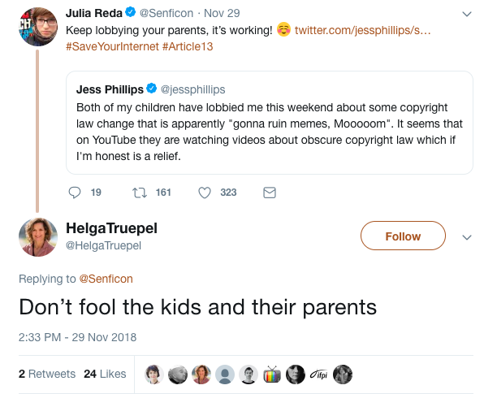

ANNEX II – Truck campaign before the European Parliament
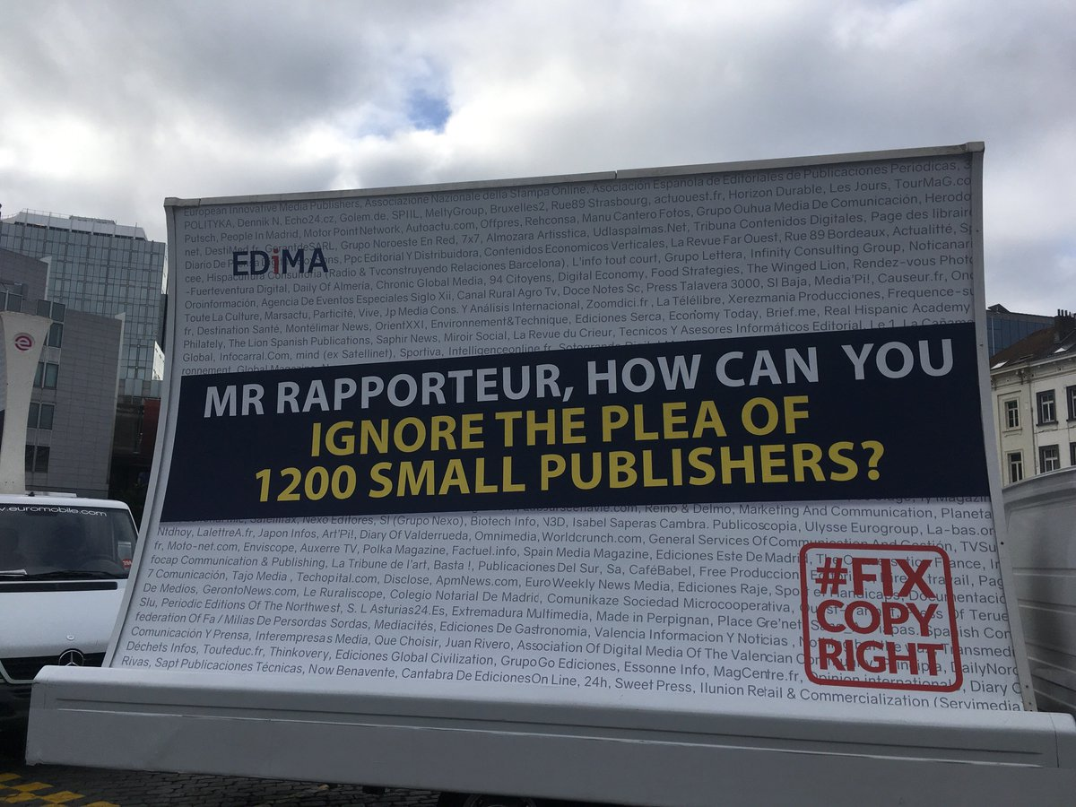
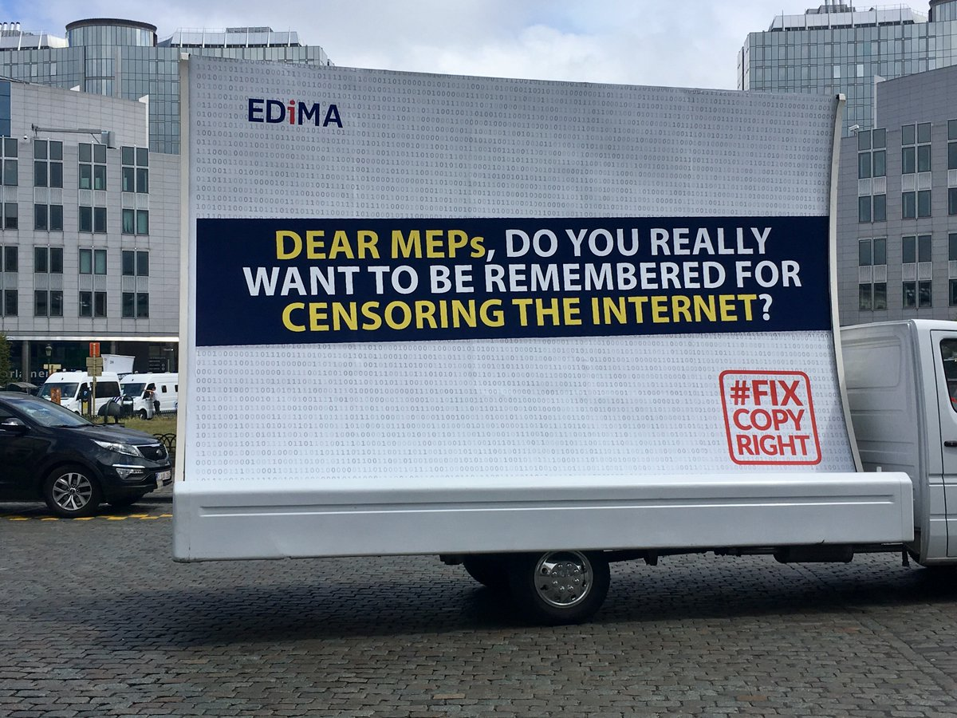

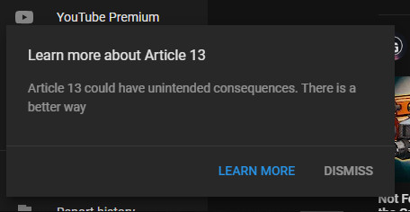
ANNEX III – YouTube campaing againts former Article 13

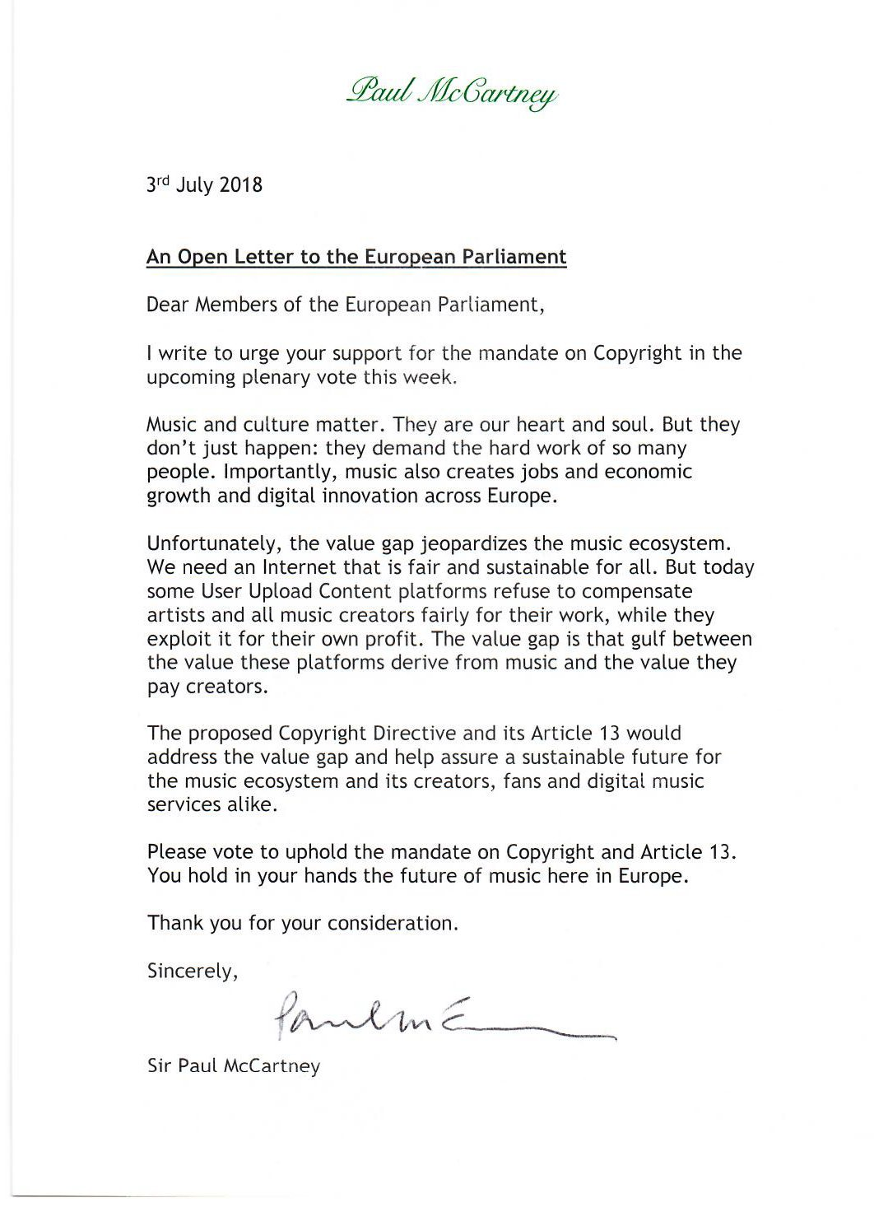
ANNEX IV – Paul McCartney’s Open Letter to the European Parliament

ANNEX V – Europe for creators campaign before September vote

ANNEX VI – Upload filters campaign targeting MEPs
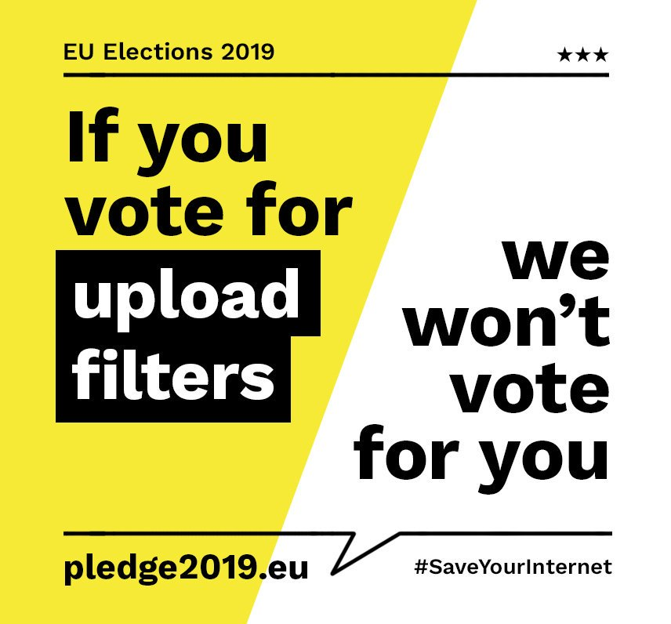

R. Collins and C. Murroni, New Media, New Policies: Media and Communications Strategy for the Future, Cambridge, Polity Press, 1996, pp. 113-115.
“Commission and its Priorities, 10 Commission priorities”, European Commission, Digital Single Market, retrieved on 26 March 2019, https://ec.europa.eu/commission/priorities/digital-single-market_en
Ibid.
European Commission, Proposal for a Directive of the European Parliament and of the Council on copyright in the Digital Single Market, (COM) 2016 593 final, 2016/0280 (COD), pp. 1-5.
European Parliament, “Copyright Law in the EU, Salient features of copyright law across the EU Member States”, EPRS European Parliamentary Research Service, Comparative Law Library Unit, PE 625.126, June 2018, pp.1-4.
European Commission, Proposal for a Directive of the European Parliament and of the Council on copyright in the Digital Single Market, loc. cit.
“Copyright Directive: competing big business lobbies drowned out critical voices”, Corporate Europe Observatory CEO, 10 December 2018, retrieved on 21 April 2019, https://corporateeurope.org/power-lobbies/2018/12/copyright-directive-competing-big-business-lobbies-drowned-out-critical-voices
M. Reynolds, “What is Article 13? The EU’s divisive new copyright plan explained”, WIRED UK, Policy, 15 April 2019, retrieved on 24 April 2019, https://www.wired.co.uk/article/what-is-article-13-article-11-european-directive-on-copyright-explained-meme-ban
“Time to Adopt the Copyright Directive”, European Publishers Council, Advertising, Audio-Visual, Intellectual Property Rights, Media Freedom, 2019, retrieved on 28 March 2019, http://epceurope.eu/time-to-adopt-the-copyright-directive/
“The #SaveYourInternet fight against Article 17 (ex Art. 13) continues”, Save Your Internet, retrieved on 5 April 2019, https://saveyourinternet.eu
F. Guadalupe, “Jean-Marie Cavada sur l’article 13: “Je n’ai jamais vu un texte qui soulève une telle propagande des GAFA” , Pure Médias, 11 March 2019, retrieved on 5 April 2019, https://www.ozap.com/actu/jean-marie-cavada-sur-l-article-13-je-n-ai-jamais-vu-un-texte-qui-souleve-une-telle-propagande-des-gafa/575837
A. Ripoll Servent, The European Parliament, London, Palgrave and Macmillan, 2018, pp. 7-25.
Ibid.
E. Ongaro, Multi-Level Governance: The Missing Linkages, Critical Perspectives on International Public Sector Management, Newcastle, Volume 4, Emerald Group Publishing Limited, 2015, pp.1-5.
E. Keller, “Noisy business politics: lobbying strategies and business influence after the financial crisis”, Journal of European Public Policy, 2016, pp.1-6.
H. Klüver, Lobbying in the European Union: Interest groups, lobbying coalitions and policy change, Oxford University Press, 2013, pp. 181-188.
E. Keller, loc. cit.
“Controversial copyright law rejected by EU Parliament”, BBC Technology News, 5 July 2018, retrieved on 31 March 2019, https://www.bbc.com/news/technology-44712475
Interview with Mr. Quentin Deschandelliers, Accredited Parliamentary Assistant of Mr. Marc Joulaud (EPP) CULT Rapporteur for Opinion, 4 February 2019.
Interview with Ms. Alina Popescu, Copyright and Digital Policy Expert at Europe Analytica, 20 February 2019.
“Copyright Directive: competing big business lobbies drowned out critical voices”, loc. cit.
C. Gehlen, “Lobbying in Brussels: The EU Directive on the Patentability of Computer-Implemented Inventions (A)”, INSEAD, 2006, p.8.
“The text of Article 13 and the EU Copyright Directive has just been finalised”, Julia Reda, Copyright reform, 13 February 2019, retrieved on 25 April 2019, https://juliareda.eu/2019/02/eu-copyright-final-text/
A. Orlowski, “YouTube fights get dirty: Kids urged to pester parents over Article 13: is this copyright battle worth it?”, The Register UK, 4 December 2018, retrieved on 27 April 2019., https://www.theregister.co.uk/2018/12/04/youtube_article_13_campaign/
Interview with Mr. Quentin Deschandelliers, loc. cit.
“A Sábado desvenda o mistério da referência a viagra de Marinho e Pinto”, Sábado Portugal, Redes Sociais, 16 July 2018, retrieved on 31 March 2019, https://www.sabado.pt/portugal/detalhe/a-sabado-desvenda-o-misterio-da-referencia-a-viagra-de-marinho-e-pinto
“Copyright Directive: competing big business lobbies drowned out critical voices”, loc. cit.
Interview with Mr. Burak Özgen, General Counsel at GESAC, Brussels, 17 April 2019.
Ibid.
I. Szczepanski, “Evidence of anti-copyright stakeholders’ harassment of MEPs in the European Parliament”, ElectronLibre, 27 June 2018, retrieved on 31 March 2019, http://electronlibre.info/evidence-of-anti-copyright-stakeholders-harassment-of-meps-in-the-european-parliament/
J. Alexander, “YouTube now runs pop-ups on videos that warn users of EU copyright proposal: an attempt to bring awareness to the issue”, The Verge, 20 November 2018, retrieved on 26 April 2019, https://www.theverge.com/2018/11/20/18104535/yotuube-pop-up-article-13-copyright-european-union-eu-warning
R. van Schendelen, The art of lobbying the EU: more Machiavelli in Brussels, Amsterdam University Press, 2013, Fourth Edition, p. 274
L. Partzsch, “The power of celebrities in global politics”, Celebrity Studies, Routledge Taylor & Francis Group, Volume 6, 2005, pp. 1-7.
A. Arthur, “Sir Paul McCartney calls on MEPs to back EU copyright law change,” The Independent, Entertainment Music, 4 July 2018, retrieved on 19 April 2019, https://www.independent.ie/entertainment/music/sir-paul-mccartney-calls-on-meps-to-back-eu-copyright-law-change-37080192.html
“Copyright Directive: competing big business lobbies drowned out critical voices”, loc. cit.
Interview with Mr. Burak Özgen, loc. cit.
Ibid.
Interview with Ms. Anna Czerwoniec, MEP Advisor to Ms. Deringer de Oedenberg (S&D Rapporteur), 21 February 2019.
Ibid.
E. Keller, loc.cit.
S. Stolton, “Copyright MEP in bomb threat scare”, Euractiv Digital, 19 March 2019, retrieved on 12 April 2019, https://www.euractiv.com/section/digital/news/copyright-mep-in-bomb-threat-scare/
A. Belu, “SaveYourInternet.eu – Citizens set to prevent upload filters in the EU”, EDRi, Press Release, 26 February 2019, retrieved on 27 April 2019, https://edri.org/saveyourinternet-eu-citizens-set-prevent-upload-filters-eu/
Twitter, Antonio Tajani, European Parliament President, 25 March 2019, retrieved on 25 April 2019, https://twitter.com/EP_President/status/1110279457703628802
Article 288, Treaty on the Functioning of the European Union (TFEU).
European Parliament, Legislative Observatory, Copyright in the Digital Single Market, Procedure file, 2016/0280 COD – Ordinary legislative procedure (ex-codecision procedure), retrieved on 10 April 2019, https://oeil.secure.europarl.europa.eu/oeil/popups/ficheprocedure.do?reference=2016/0280(COD)&l=en
Ibid.
“The #SaveYourInternet fight against Article 17 (ex Art. 13) continues”, loc. cit.
“A major achievement for Europe: GESAC welcomes the adoption of the Copyright Directive”, GESAC, 15 April 2019, retrieved on 22 April 2019, http://authorsocieties.eu/mediaroom/339/33/A-major-achievement-for-Europe-GESAC-welcomes-the-final-adoption-of-the-Copyright-Directive
K. Walker, “EU Copyright Directive: one step forward, two steps back”, Google in Europe, 3 March 2019, retrieved on 21 April 2019, https://www.blog.google/around-the-globe/google-europe/copyright-directive-one-step-forward-two-steps-back/
L. Kayali, “Winners and losers of Europe’s copyright reform”, POLITICO, 14 February 2019 (updated on 19 April 2019), retrieved on 27 April 2019, https://www.politico.eu/article/copyright-platforms-eu-google-winners-and-losers-of-europes-copyright-reform/
L. Kayali, loc. cit.
Interview with Mr. Burak Özgen, loc. cit.
L. Kayali, loc. cit.
European Parliament, Legislative Resolution on the proposal for a directive of the European Parliament and of the Council on copyright in the Digital Single Market, op. cit., p.131.
L. Kayali, loc. cit.
Ibid.
L. Kayali, loc. cit.
Interview with Ms. Laura Kayali, Tech Reporter at POLITICO, 11 April 2019.
E. Ongaro, loc. cit.
Interview with Mr. Burak Özgen, loc. cit.
A. Orlowski, loc. cit.
Twitter, EDiMA EU, 2018, retrieved on 31 March 2019. https://twitter.com/EDiMA_EU/status/1009070602827821056
J. Alexander, loc. cit.
Twitter, IFPI, Representing the recording industry worldwide, 4 July 2008, retrieved on 19 April 2019, https://twitter.com/IFPI_org/status/1014429611176972288/photo/1?ref_src=twsrc%5Etfw%7Ctwcamp%5Etweetembed%7Ctwterm%5E1014429611176972288&ref_url=https%3A%2F%2Fwww.independent.ie%2Fentertainment%2Fmusic%2Fsir-paul-mccartney-calls-on-meps-to-back-eu-copyright-law-change-37080192.html
“Copyright Directive: competing big business lobbies drowned out critical voices”, loc. cit.
Twitter, Epicenter Works, 2019, retrieved on 26 April 2019, https://twitter.com/epicenter_works/status/1099953416233611265

